# Sequence Diagrams

## שיבוץ עובדים למשמרות

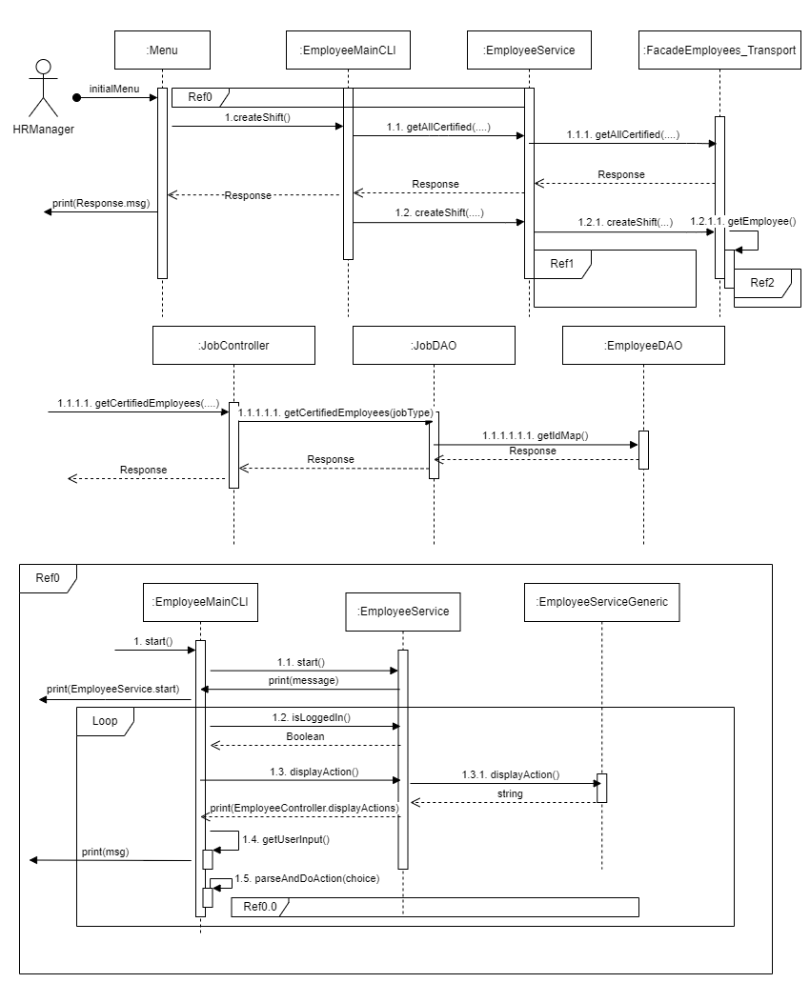

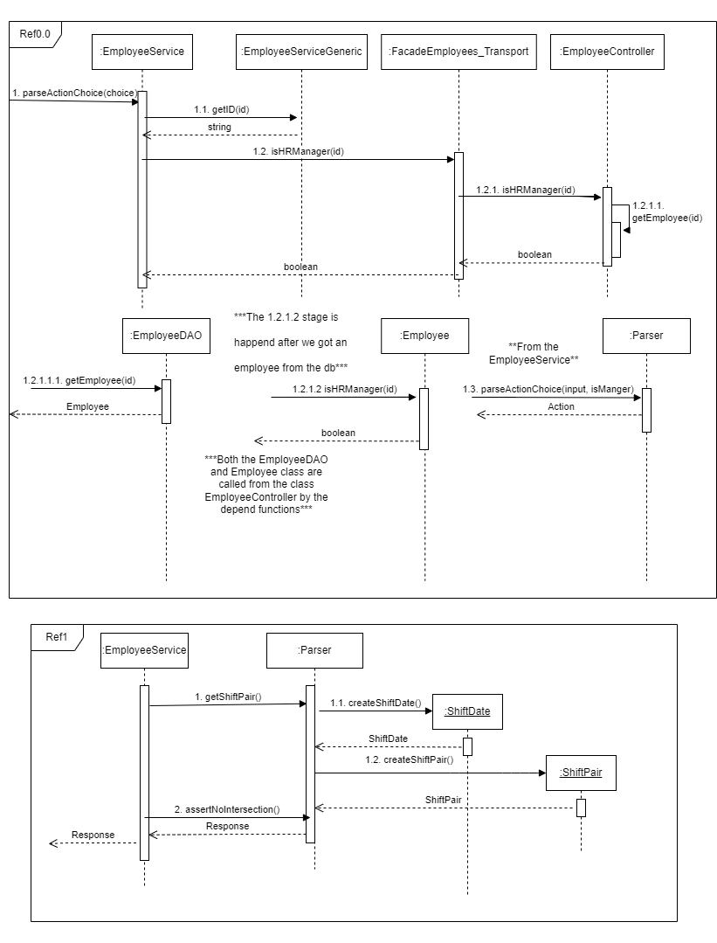

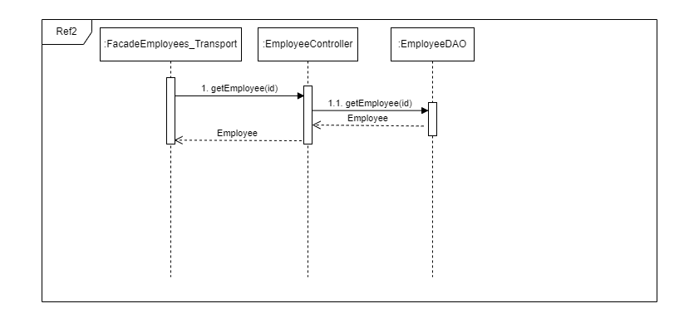

## הוצאת הזמנה תקופתית מספק

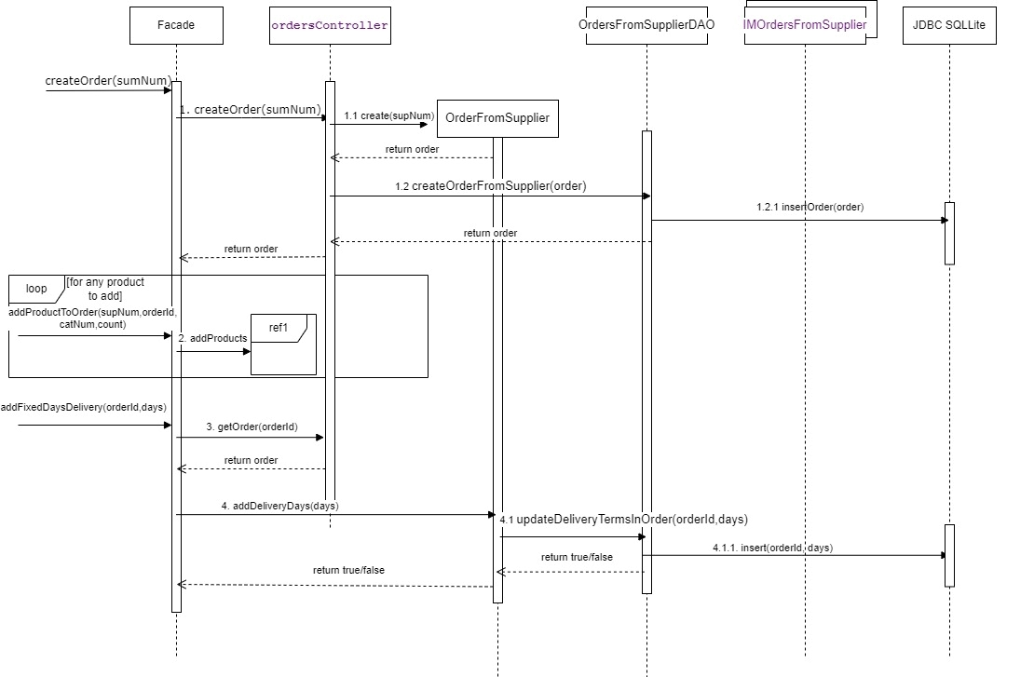

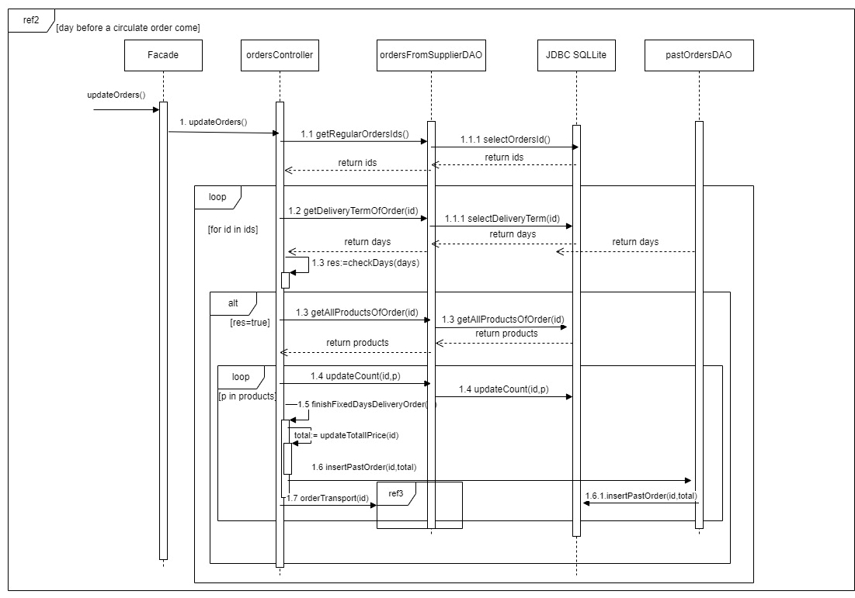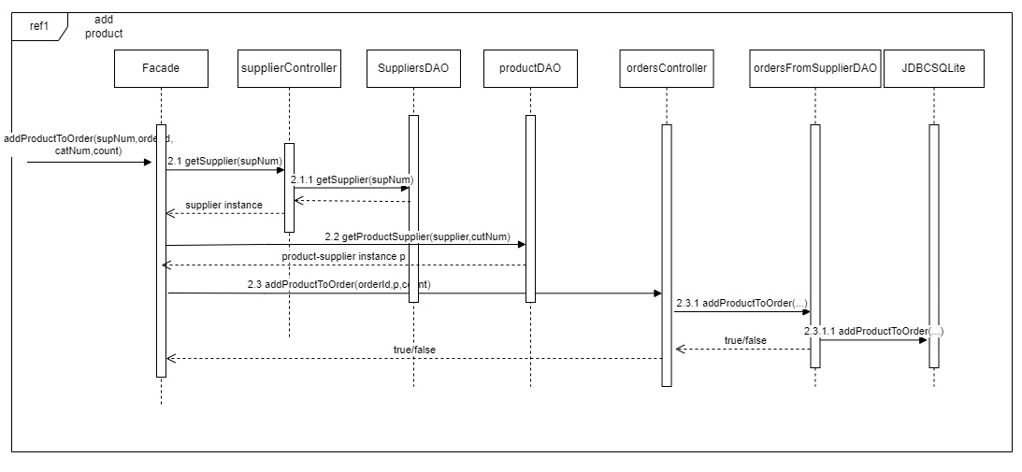

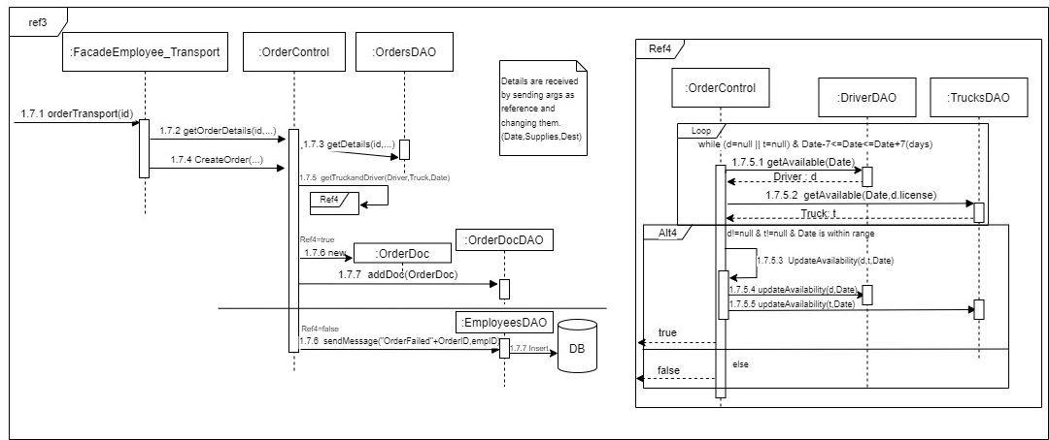

## קבלת הובלה ועדכון מלאי.

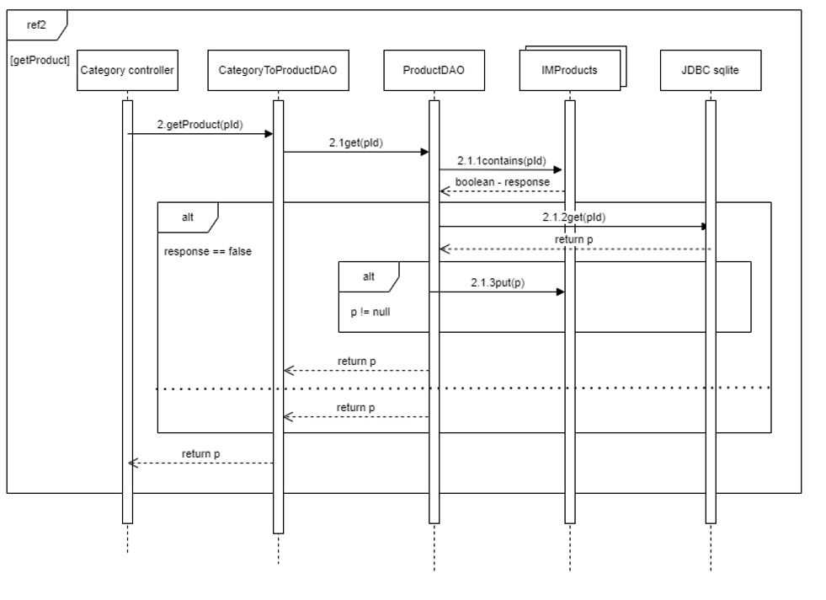

# DFD

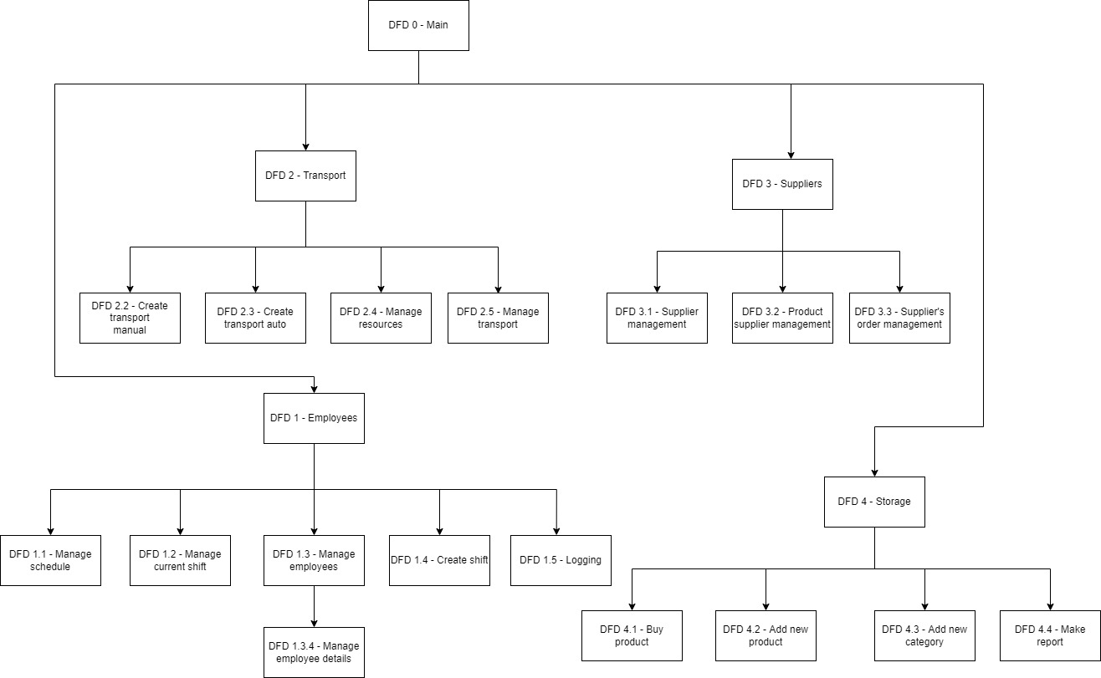

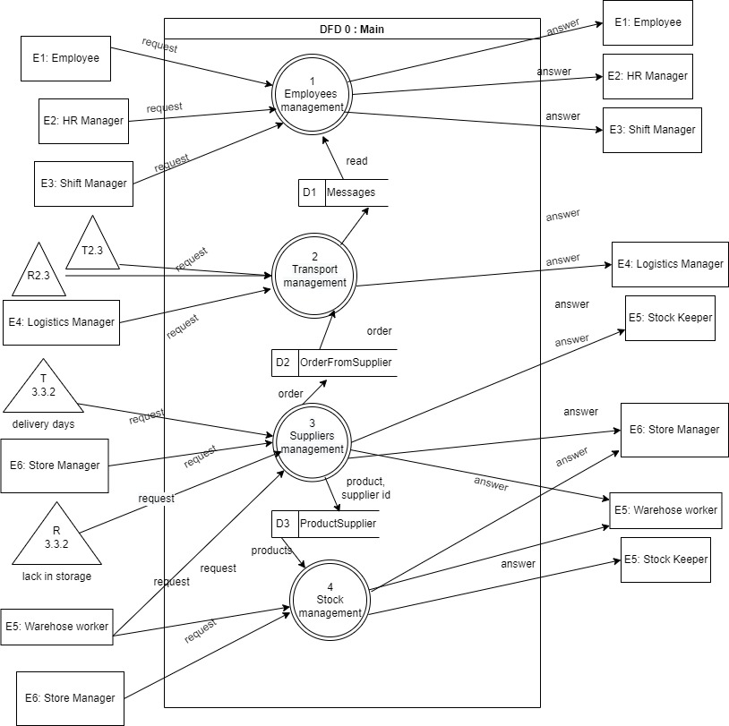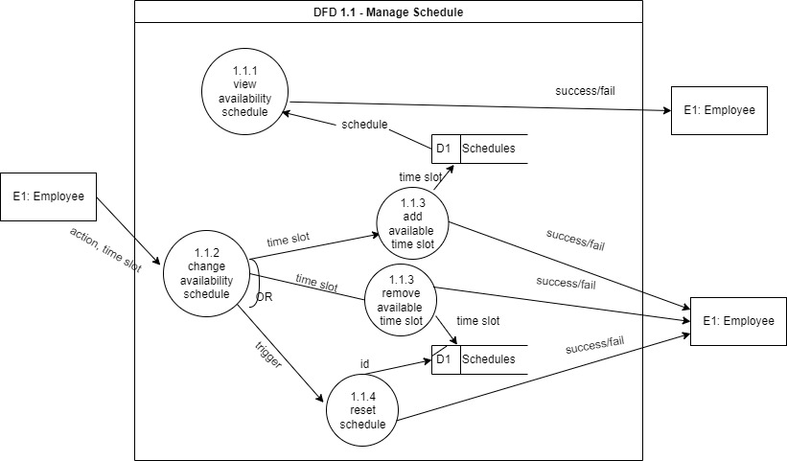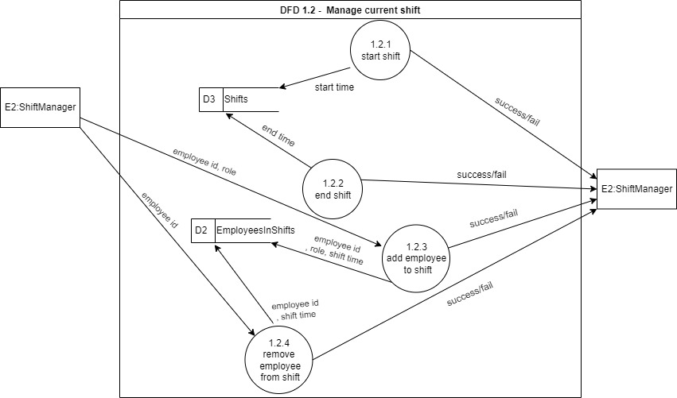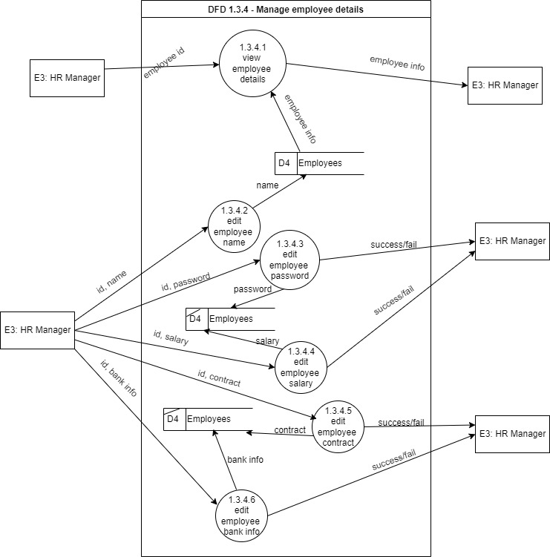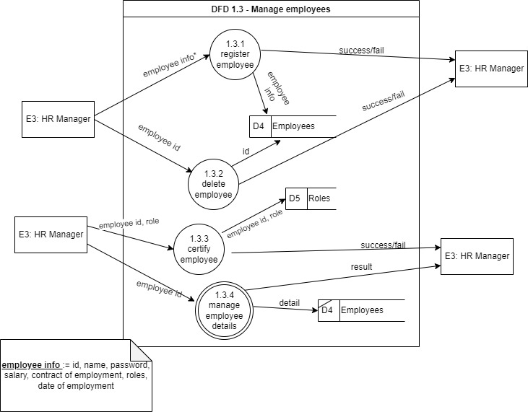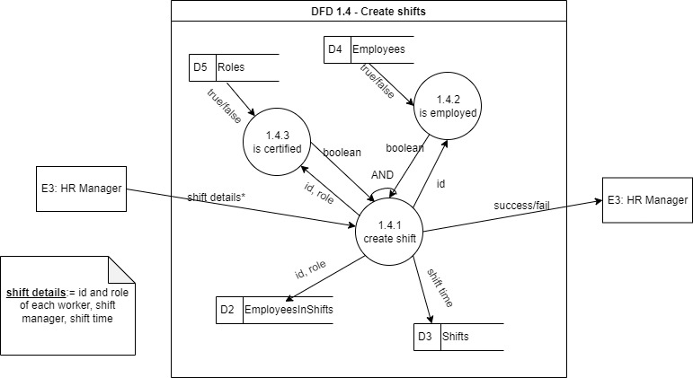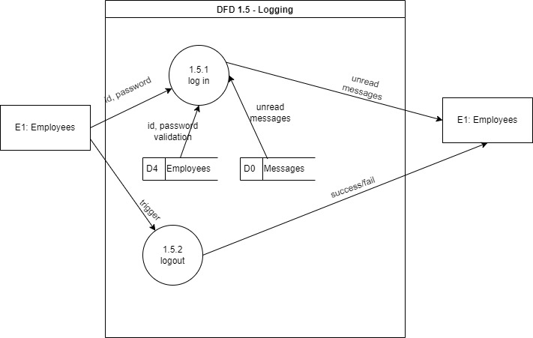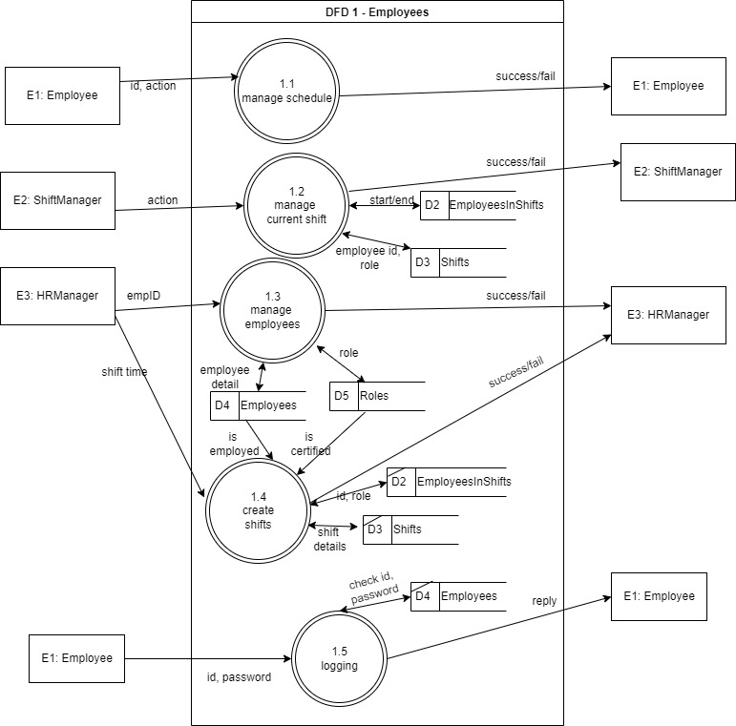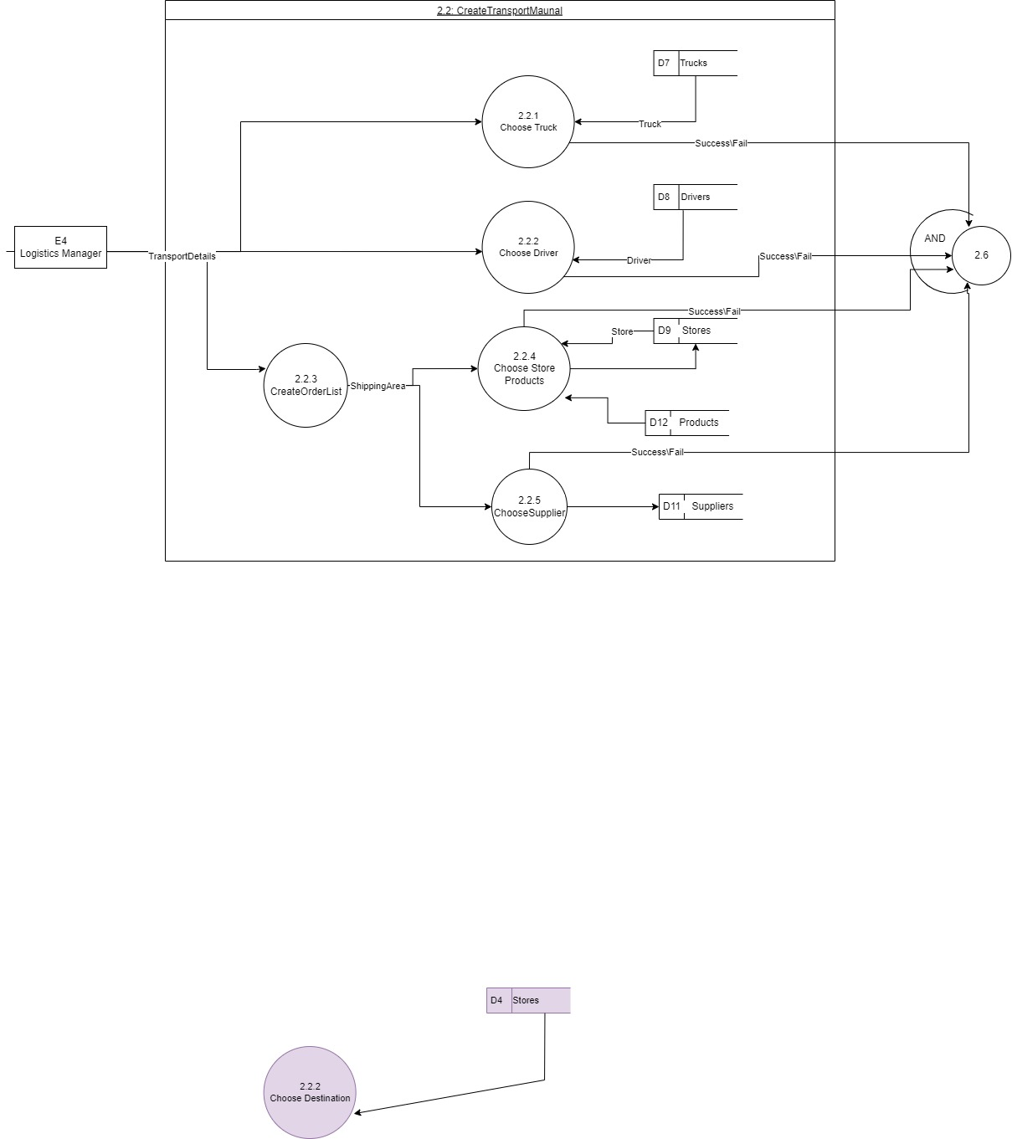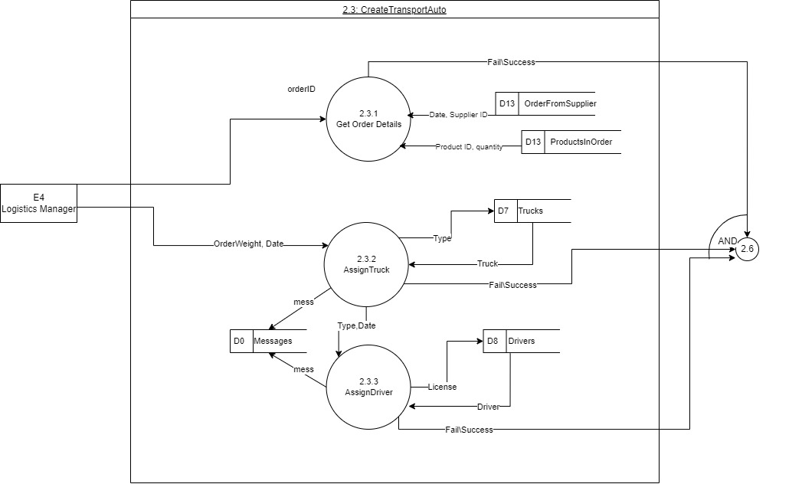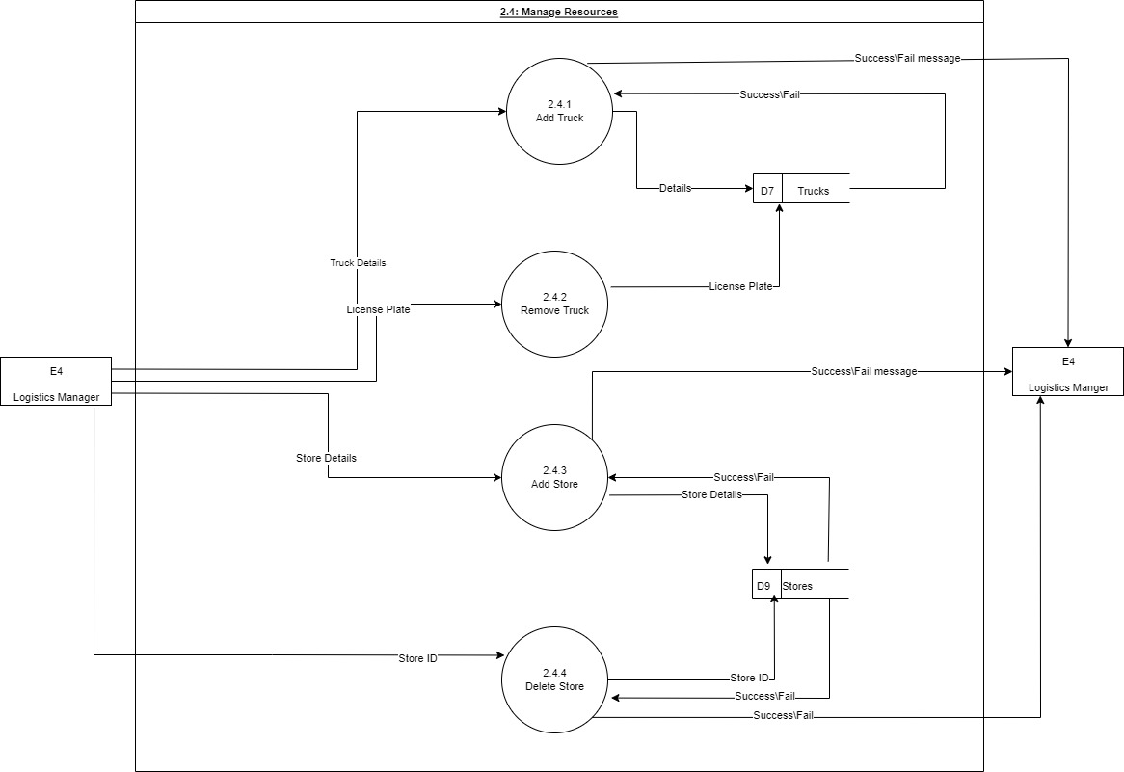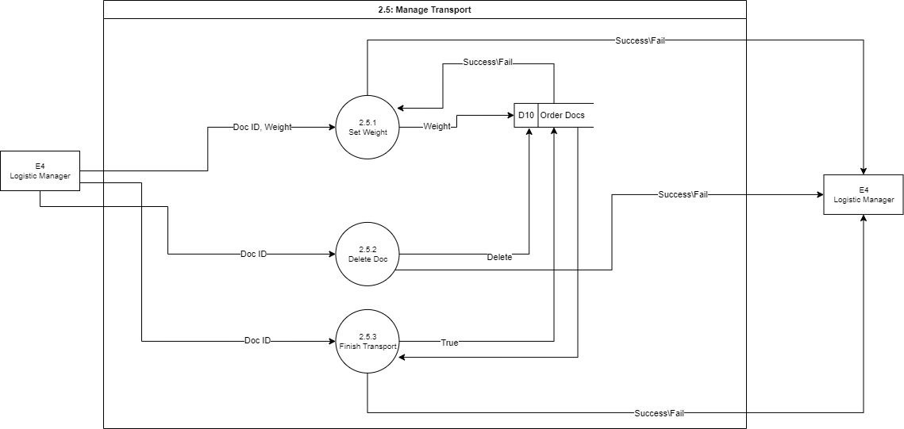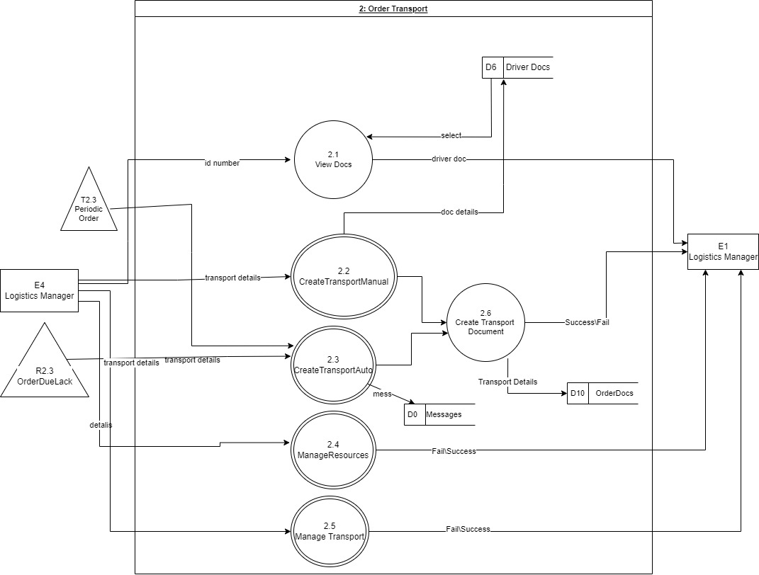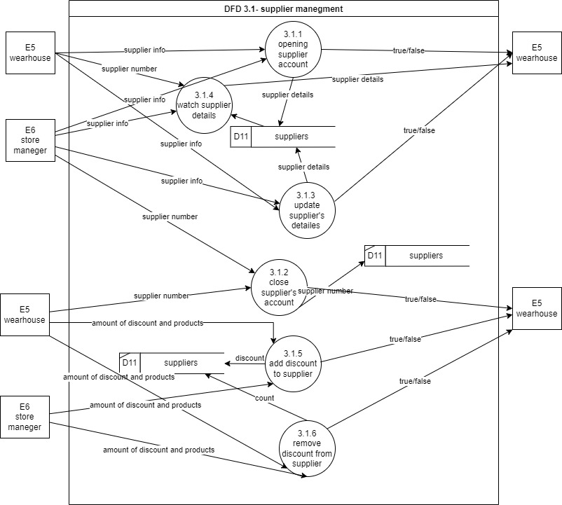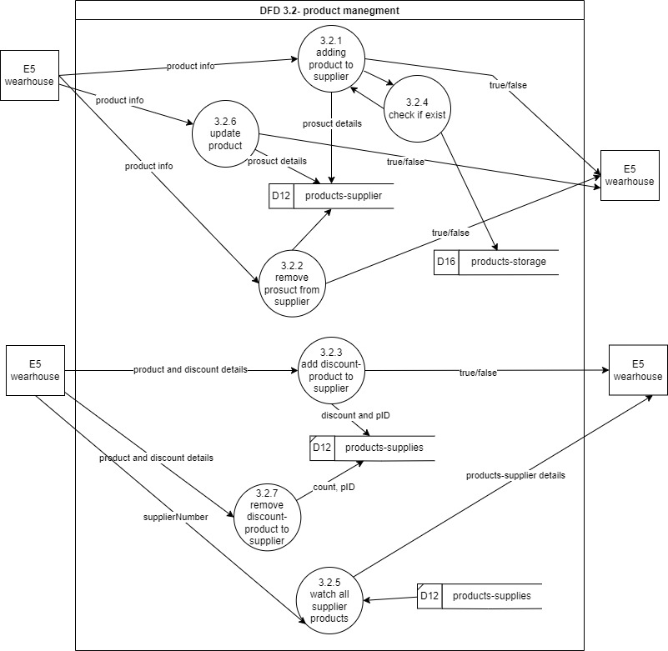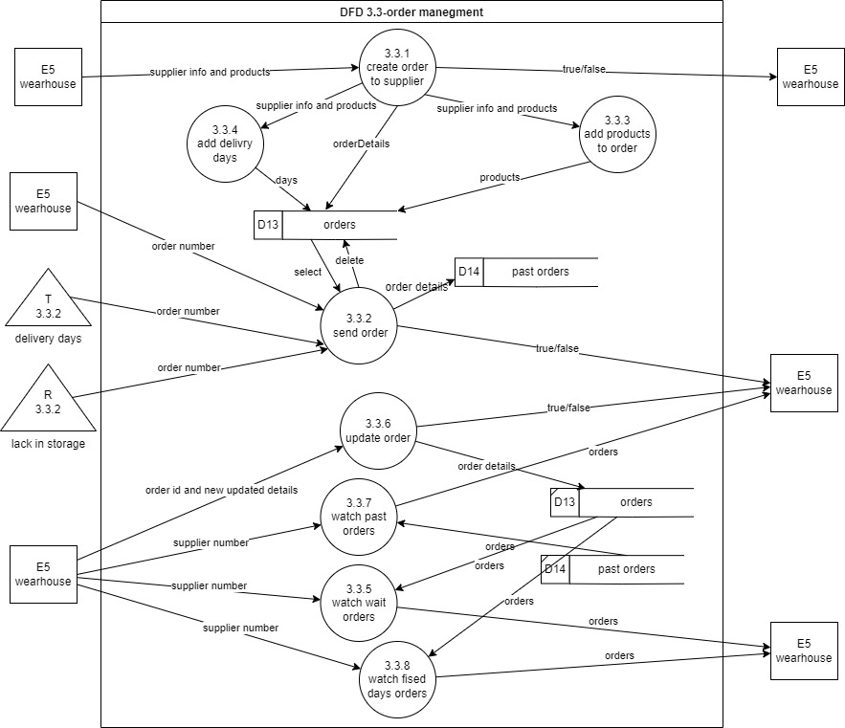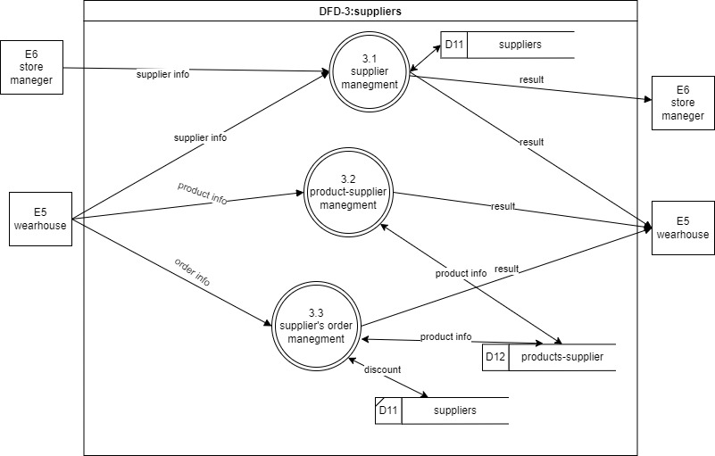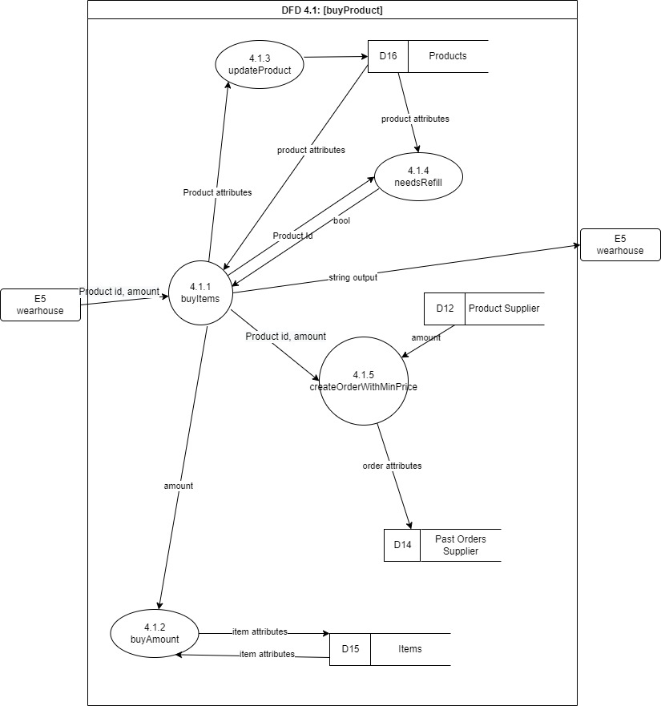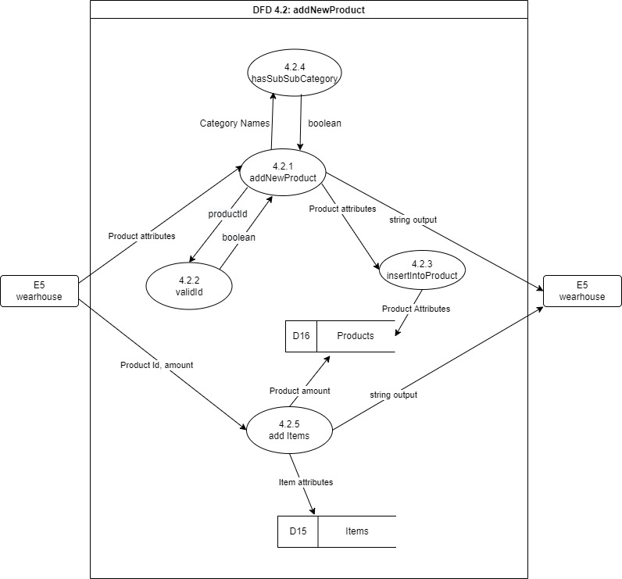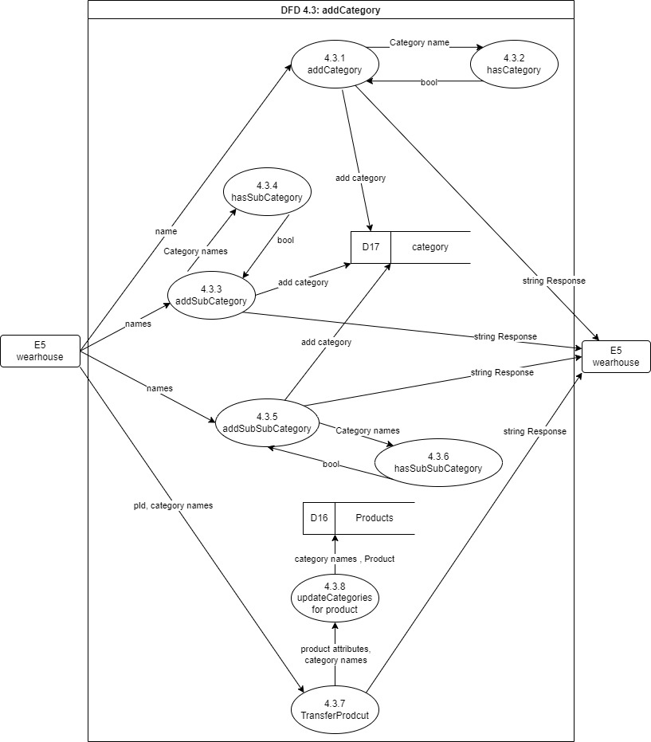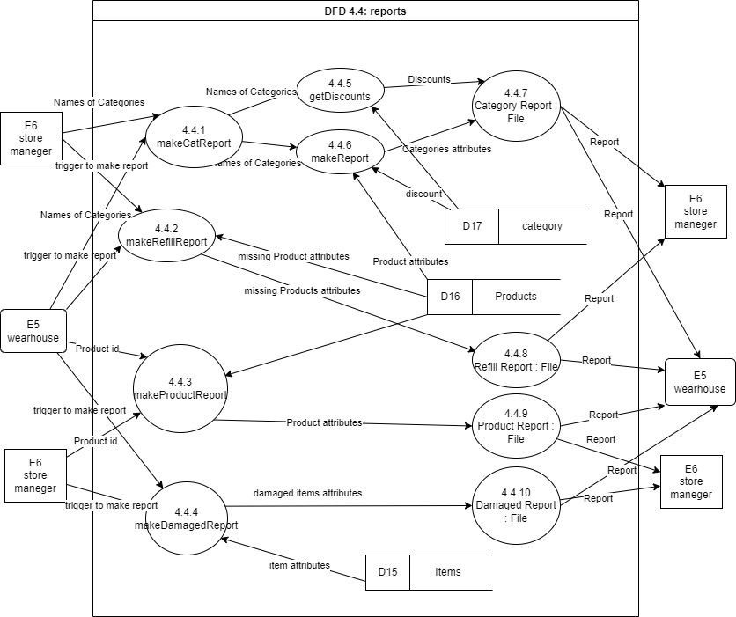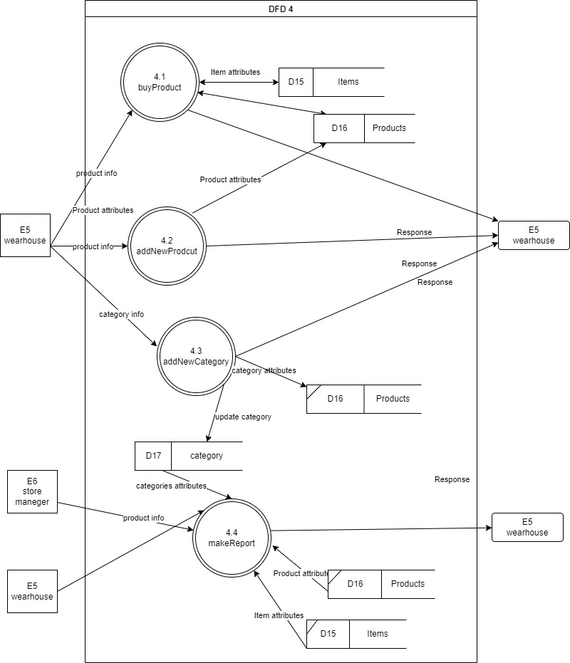

# עץ תפריטים

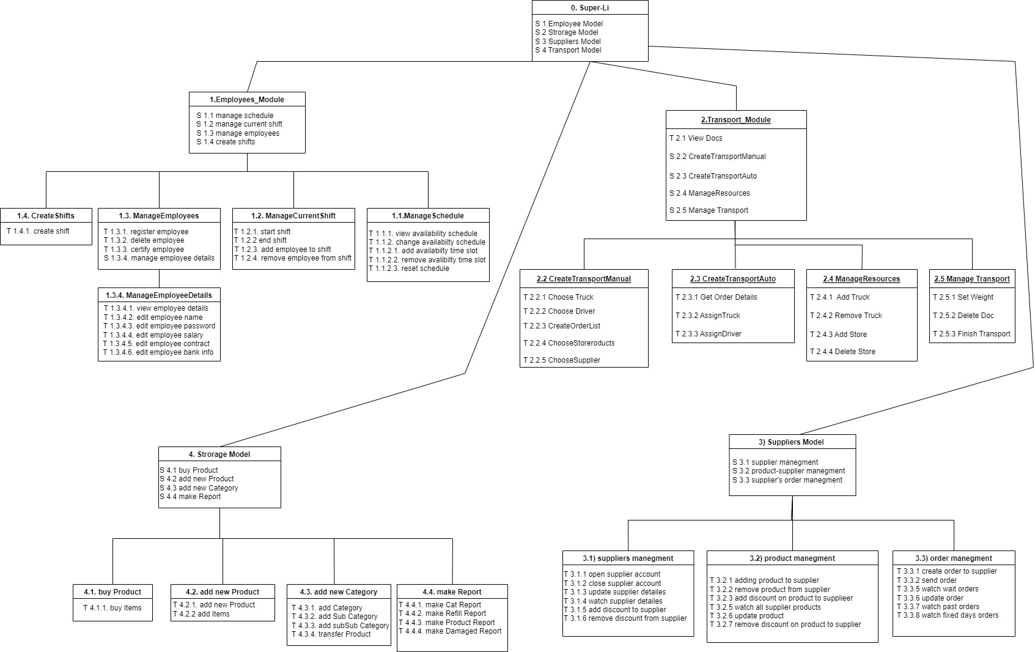

# Changes that happened In the integration of all the modules:

1. the database will now have all the tables and information from all the modules without duplicates.
2. Every function from every module can be called from the faced.
3. The storage can now get transport and update the products in storage according to the order
4. Every transport can now be finished by getting to the storage
5. For every order from supplier there will be a transport that will make that order.
6. For every role of worker there will permission, which means that each type of worker can do only the functionality that his role is allowed.

# נספחים מעבודות קודמות

## Requirements

|  |  |  |  |  |  |  |
| --- | --- | --- | --- | --- | --- | --- |
| Status | Risk | Priority | Description | F/NF | Module | ID |
| DONE | LR | MH | The system needs to be able to open supplier account | F | Suppliers |  |
| DONE | LR | MH | The system must manage for each supplier the necessary details: account number, bank account, payment agreement, save contacts and their contact Information | F | Suppliers |  |
| DONE | HR | MH | The system must manage the products which each supplier can supply with their price and catalog number at the supplier | F | Suppliers |  |
| DONE | HR | MH | The system must save for each product of the same supplier a unique catalog number | F | Suppliers |  |
| DONE | HR | NTH | The system may give discount for a supplier base on the number of products in order | F | Suppliers |  |
| DONE | HR | NTH | The system may give discount for a supplier base on the number of specific products in an order | F | Suppliers |  |
| DONE | HR | MH | The system must be able to create a new order from a supplier | F | Suppliers |  |
| DONE | LR | MH | When open an order the system must save the creation date | NF | Suppliers |  |
| DONE | HR | NTH | The system should transfer the order details to the supplier's system | F | Suppliers |  |
| DONE | LR | MH | The system needs to save for each order who is the deliver, "Super Li" or the supplier | F | Suppliers |  |
| DONE | LR | MH | The system needs to be able to save for supplier Fixed delivery days. | F | Suppliers |  |
| DONE | HR | MH | The system will allow authorized user to update the Product list of a supplier that has fixed delivery days before, each delivery | F | Suppliers |  |
| DONE | LR | NTH | The system should save all the past orders | NF | Suppliers |  |
| DONE | LR | MH | The system will save for every product's his minimal amount using the demand to know if there is enough in stock | F | Storage |  |
| DONE | LR | MH | The system will alert in the case that a product reached its minimal amount | F | Storage | 1. 18 |
| DONE | LR | MH | The system will save all the products and be able to get each product | F | Storage | 1. 19 |
| DONE | HR | NTH | The system will follow products that are out of stock | NF | Storage | 1. 20 |
| DONE | HR | MH | The system will save the locations of every product in the store (storage shelf number, store shelf number) | F | Storage | 1. 21 |
| DONE | LR | NTH | The system will save who is the manufacturer for every product | F | Storage | 1. 22 |
| DONE | LR | MH | The system will save the current amount of every product in the store | F | Storage | 1. 23 |
| DONE | LR | MH | The system will save current amount for every product in storage | F | Storage | 1. 24 |
| DONE | LR | MH | The system will save the price and the cost of every product | F | Storage | 1. 25 |
| DONE | HR | MH | The system will save the current discount for every product | F | Storage | 1. 26 |
| DONE | HR | MH | The system will allow for authorized users to change the discount of every product if it is needed | F | Storage | 1. 27 |
| DONE | LR | MH | The system will be able to create new categories | F | Storage | 1. 28 |
| DONE | HR | MH | The system will save for every category the products that are inside. | F | Storage | 1. 29 |
| DONE | LR | MH | The system will allow authorized users to change the discount of every category | F | Storage | 1. 30 |
| DONE | HR | MH | The system will allow for every category to create new subcategory | F | Storage | 1. 31 |
| DONE | HR | MH | The system will allow for every subcategory to create new sub subcategory | F | Storage | 1. 32 |
| DONE | LR | MH | The system will allow to insert a given product to given categories | F | Storage | 1. 33 |
| DONE | HR | NTH | The system will be able to produce a product report for every product that will include amount in store, amount in storage, minimal amount, if the product needs a refill and how much needs to be ordered so that the amount will be larger than the minimal amount | F | Storage | 1. 34 |
| DONE | HR | MH | The system will be able to produce category reports which includes every product in the category and its details | F | Storage | 1. 35 |
| DONE | LR | MH | The system will allow authorized users to report damaged items | F | Storage | 1. 36 |
| DONE | LR | MH | The system will follow and save the damaged items | F | Storage | 1. 37 |
| DONE | LR | MH | The system will allow to produce a report which includes all the damaged items that were reported | F | Storage | 1. 38 |
| DONE | LR | MH | The system will allow to produce refill report that includes all the products that need to be refilled | F | Storage | 1. 39 |
| DONE | HR | MH | The system will place an order from supplier of a product when the product amount is less than its minimal amount | F | Storage/  Supplier | 1. 40 |
| DONE | HR | MH | In order of fixed delivery days, the system will check a day before the delivery date the supplies in storage and update the amounts in the order according to the storage amount | F | Storage/  Supplier | 1. 41 |
| DONE | HR | MH | When creating a refill order the system will update the order so that every product in the order after the order occurred will have more than the minimal amount | NF | Storage/  Supplier | 1. 42 |
| DONE | HR | MH | Before creating a refill order the system will compare supplier prices for each supplier and will order from the supplier with the cheapest price | NF | Storage/  Supplier | 1. 43 |
| DONE | HR | MH | The system will save for each employee the days and hours in the week which he can work in | F | Workers | 1. 44 |
| DONE | HR | MH | The system will save for each employee the roles he can work in | F | Workers |  |
| DONE | HR | MH | The system will be able to assign the employees to shifts and allow the HR manager to decide who will do each role | F | Workers | 1. 45 |
| DONE | HR | MH | The system will allow the shift manager to add/remove employees to a given shift | F | Workers | 1. 46 |
| DONE | HR | MH | The system will allow every employee to sign in the schedule that he can work at and change it if needed | F | Workers | 1. 47 |
| DONE | LR | MH | The manager will be able to change the details of workers in the system | F | Workers | 1. 49 |
| DONE | HR | MH | The system will allow to certify employees to different positions | F | Workers | 1. 50 |
| DONE | LR | MH | The system will display an error message if a shift manager wasn’t assigned to a shift | F | Workers | 1. 51 |
| DONE | LR | MH | The shift manager is certified to scan a cancellation card in the register | F | Workers | 1. 52 |
| DONE | LR | MH | The system will allow the manager to manage his employees | F | Workers | 1. 53 |
| DONE | LR | MH | The system will save for each employee the following details: name, id, bank details, salary, starting date, terms and conditions | F | Workers | 1. 54 |
| DONE | LR | NTH | The system will allow the manger to add new positions | F | Workers | 1. 55 |
| DONE | HR | NTH | To every position the system will show a list of people that can be assigned to it | F | Workers | 1. 56 |
| DONE | HR | NTH | The system will not allow employees to change shifts in which they can work until the shift manager hasn’t done assigning them | F | Workers | 1. 57 |
| DONE | HR | NTH | The system will save the shift history and details up to six months back | NF | Workers | 1. 58 |
| DONE | HR | NTH | The system will allow to change shifts between employees | F | Workers | 1. 59 |
| DONE | LR | MH | The shifts in the system will be divided to morning and evening shifts | NF | Workers | 1. 60 |
| DONE | LR | MH | In every shift there must be a shift manger | NF | Workers | 1. 61 |
| DONE | HR | MH | In every shift there will be at least one person in each of following roles: warehouse worker, shelf worker, register worker, driver, shift manger | NF | Workers | 1. 62 |
| DONE | LR | MH | The manager positions work only in the morning shifts | NF | Workers | 1. 63 |
| DONE | LR | MH | The system should alert the user if a truck is not suited for the transport | F | Transport | 1. 64 |
| DONE | HR | MH | the system will save for every destination in transport a document which includes a list of products that are transported to this destination | F | Transport |  |
| DONE | HR | MH | The system needs to allow the user to create new transport | F | Transport | 1. 65 |
| DONE | LR | MH | When the truck weight exceeds the max weight, the system needs to alert and allow the user to either change the supplies, destinations or truck | F | Transport | 1. 66 |
| DONE | LR | NTH | The system will allow authorized user to view all the transport documents that exists in the system | F | Transport | 1. 67 |
| DONE | LR | MH | The system will save for each supplier and store its transport area | NF | Transport | 1. 68 |
| DONE | LR | MH | The system should save all the transports created | NF | Transport | 1. 69 |
| DONE | HR | NTH | The system will manage drivers, trucks, suppliers and sites | F | Transport | 1. 70 |
| DONE | LR | MH | The system must be able to assign a driver to a truck according to their licenses, truck’s type and availability | F | Transport | 1. 73 |
| DONE | LR | NTH | The system will save for every transport a transport document that will contain the following details: origin location, destination, date, departure hour, truck number and driver's name | F | Transport | 1. 74 |
| DONE | LR | MH | Before a truck is leaving the needs to be able to save the weight of the truck in the transport document | F | Transport | 1. 75 |
| DONE | LR | MH | The system will save for each driver his driving licenses | F | Transport | 1. 76 |
| DONE | HR | MH | The system will save for every truck its: license plate, module, starting weight (without any additional weight) and maximum weight | F | Transport |  |
| DONE | LR | MH | The system will save for every site: address, phone number and contact’s name | F | Transport | 1. 77 |
| DONE | HR | NTH | The system will calculate the total weight of the order after the user finished creating the order | F | Transport | 1. 79 |
| DONE | LR | MH | The system will save every transport in transport manager | F | Transport |  |
| DONE | HR | MH | The system needs to allow drivers to be assigned in to shifts | F | Transport/  Workers | 1. 82 |
| DONE | LR | MH | The system will check that for transport the driver is assigned to the shift that the transport took place in | F | Transport/  Workers |  |
| DONE | HR | MH | The system will allow the driver to sign in as worker | F | Transport/  Workers | 1. 83 |
| DONE | HR | MH | The system will check that for every transport there is a driver assigned to it | F | Transport/  Workers | 1. 84 |
| DONE | HR | MH | The system will check for each transport that the license of the driver allows him to drive the truck type | F | Transport/  Workers | 1. 85 |
| DONE | HR | MH | The system will make sure that every time there is a transport there must be a warehouse worker to receive the transport in each shift | F | Transport/  Workers | 1. 86 |
| DONE | HR | MH | The system must have a database that will store all the necessary details for each module | NF | All modules | 1. 87 |
| DONE | HR | MH | The system will assign driver for each order from a supplier that super li is responsible for the transportation | F | All modules | 1. 88 |
| IN PROGRESS | HR | MH | The system will assign for every order from supplier a transport that will take into account the supply days and the driver schedules when setting a date for the transport | F | All modules |  |
| IN PROGRESS | HR | MH | The system will alert the HR manager in case a transport cannot be set to accrue in the following week from when the order from the supplier was ordered, and will allow him to change the schedules of the drivers in a way that will allow the transport to accrue in the following week | F | All modules |  |
| IN PROGRESS | HR | MH | The system will allow to cancelation of an order only with the approval of the warehouse worker, logistics manager and HR manager. | F | All modules |  |
| IN PROGRESS | HR | MH | When a transport arrives, the system will allow the warehouse worker to approve the transport and products in storage will be updated accordingly. | F | All modules |  |
| IN PROGRESS | HR | MH | When a transport arrives, the system will allow the warehouse worker to check and report on missing or defected items and update the order and products in storage accordingly | F | All modules |  |
| IN PROGRESS | HR | MH | When ordering from supplier or updating the storage the system will save the product's catalog number according to the store catalog number of that product and not according to the catalog number of the supplier | NF | All modules |  |
| IN PROGRESS | LR | MH | The system will allow each role to do only the functionality that the role is permitted to do | F | All modules |  |
| IN PROGRESS | LR | MH | The warehouse worker is permitted to manage the storage and order supplies from the supplier's | F | All modules |  |
| IN PROGRESS | LR | MH | The system will allow the warehouse worker and the store manage to manage the supplier system. | F | All modules |  |
| IN PROGRESS | LR | MH | The system will allow only the logistics manager to manage the orders and transports. | F | All modules |  |
| IN PROGRESS | LR | MH | The system will display for each actor the functionalities that he can do. | F | All modules |  |

## Concepts of the system:

Supplier: someone who supplies products to the store.

Order: a list of products and there amounts that the supplier will provide in a number of days.

Product: a product that the store will sell and manage.

Item: an instance of a product that will have its own expiration date and location in the store.

Authorized user: someone that may interact with the system and do actions such as: make orders, add items and products.

Category: a set of products that have something in common for example: dairy products.

Site: location of super li store or a location of supplier's store/factory.

shift: a time in the day which workers work in.

demand: the average amount a product is sold in a day.

Refill order: an order that was placed because of a shortage in product amount.

Fixed days delivery order: an order that occurs in a fixed number of days.

## Assumptions for the system:

* The system should not work on Saturday
* The payment between supplier and super li will be made outside of the system.
* The system will be used in the storage office.
* The system will calculate a discount in the following way: First, calculate on the amount of product and then add the discount on the numbers of items in the order.
* The system will allow to make a report whenever an authorized user would like.
* The system will account the damaged items and will not include them in the product amount.
* An item location is determined by if it is in the STOREAGE or in the STORE and by its shelf number.
* Every product can be in only one category
* For every product the discount that applies to it, is the last discount that has entered the system.
* There are only category, subcategory and sub subcategory.
* The demand of a product is the average times it was sold in each day.

## תרשים use case diagram

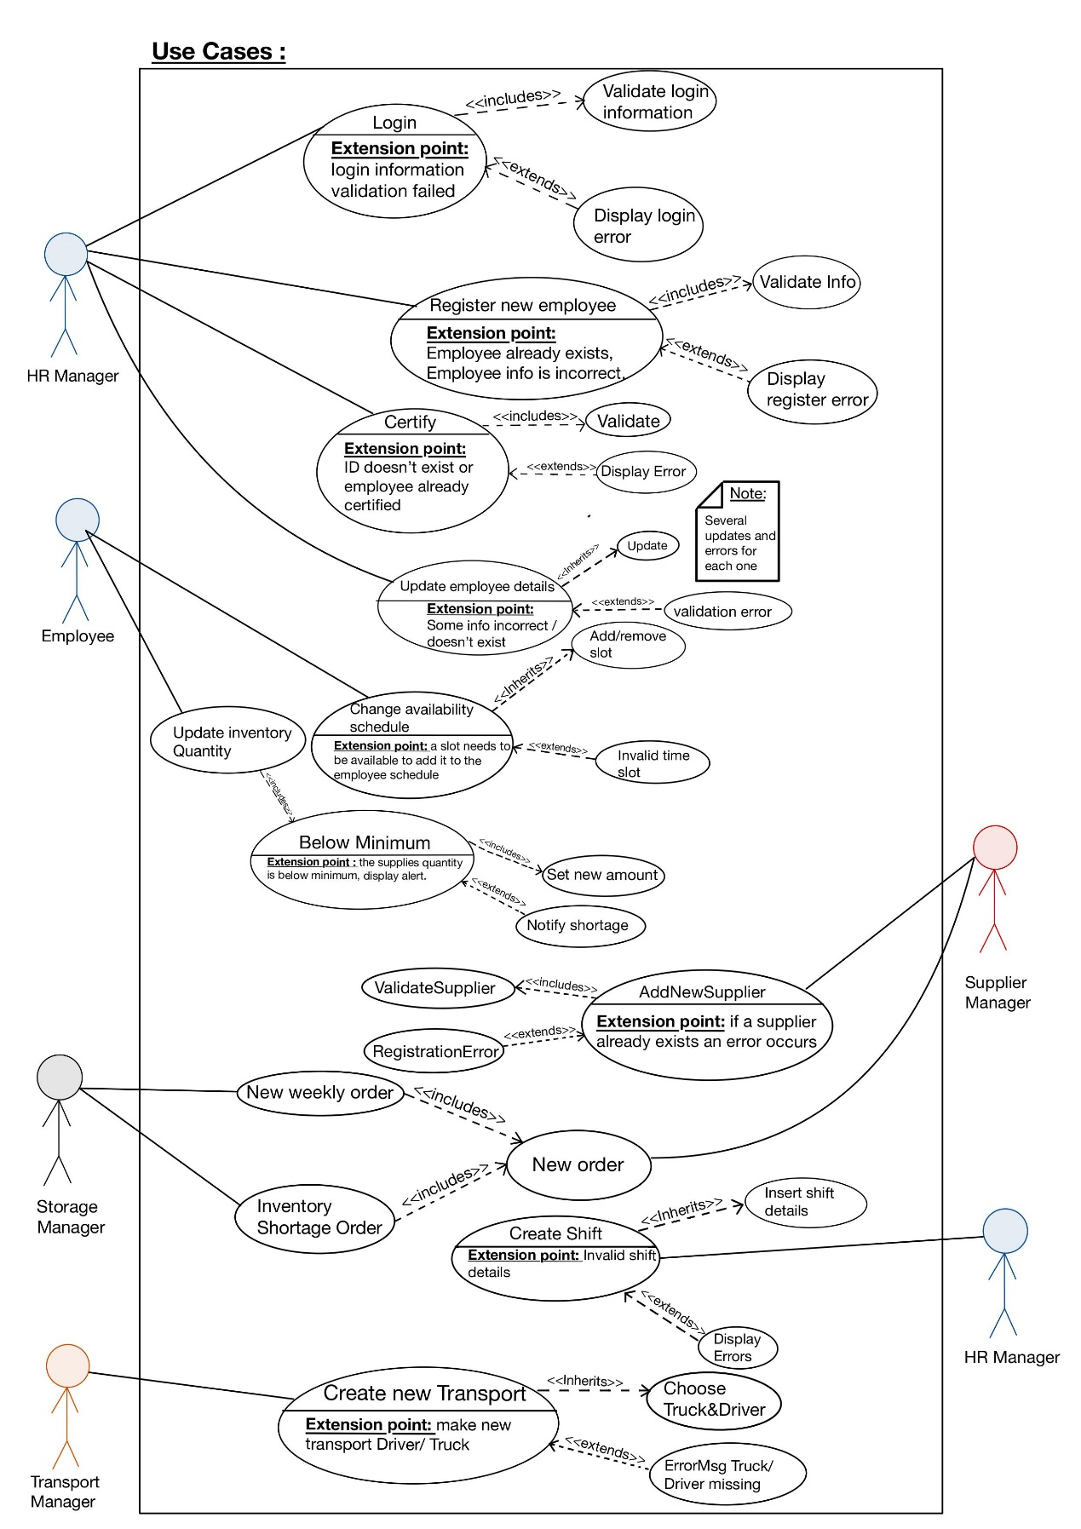

### Use case e:

* name: create circulating order
* Textual Description: Create an order that will be sent in a fixed days
* List of Actors: Warehouse worker
* Pre-conditions: The chosen supplier exist in the system
* Post-conditions:
  1. A required supplier is chosen
  2. An Order instance o was created
  3. A Product instances were created by demand
  4. Each product p was associated with the current order
  5. The order o gets amount for each product p
  6. The current order o was associated with the Store (to add it to the historical orders)
* Main success scenario:
  1. Worker chooses supplier
  2. Worker creates a circulating order
  3. Worker adds product and amounts to the order
  4. Worker send/save the order
* Alternatives/Extensions:

A* in any point the: system fails- need to recovery the system.

1. the worker choose supplier that isn't exist: the system signals the error to the worker

2. the worker choose the same product multiple times: the system signals the error to the worker

3. the worker choose the same day twice or invalid day (i.e. 8,9, -1): the system signals the error to the worker

### Use case f:

* Name: create order due to lack
* Textual Description: Creating an order that will be sent when there is a lack of particular product
* List of Actors: Warehouse worker
* Pre-conditions:
  1. The worker specific min amount to product
  2. The worker specify amount to refill
  3. The amount of the specific products reached to the minimum
  4. The chosen supplier exists in the system
* Post-conditions: (after the trigger is triggered)

1. An Order instance o will be created
2. A Product instances will be created
3. Each product p was associated with the current order o
4. The order o gets an amount product p
5. The current order was associated with the Store (to add it to the historical orders)

* Main success scenario: (When there is a lack of this product)

1. The system selects the supplier with the cheapest‏ price on the product
2. The system creates a new order to this supplier
3. The systemaddstheproduct and amount to the order
4. The system send\save the order

* Alternatives/Extensions:

A* in any point the: system fails- need to recovery the system.

1. the worker choose product that isn't exist: the system signals the error to the worker

2. the worker specify invalid amount to refill: the system signals the error to the worker

3. there is no supplier which supply the specific product: the system signals the error to the worker

### Use case G:

* Use case name: Creating a new shift.
* Textual Description: an HR manager will choose to create a new shift, choose a time slot and add employees based on their certification in system.

An error will display if a time slot isn’t available, employee isn’t certified for a specific role or employee already assigned.

* List of actors: HR -Manager
* Pre-conditions: there isn’t a shift assigned to the specific time slot, HR manager is logged in.
* Post-condition: all employees appear assigned to the shift.
* Main success scenario:

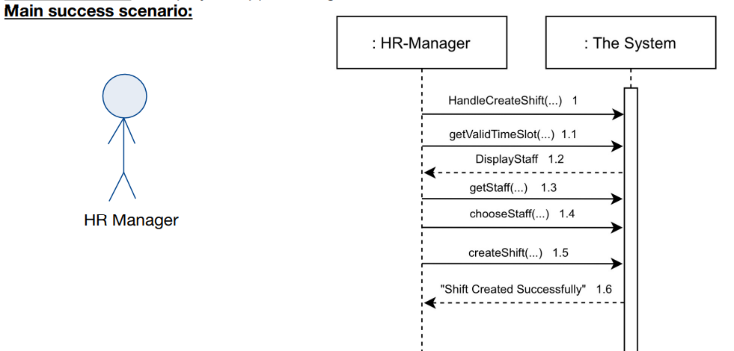

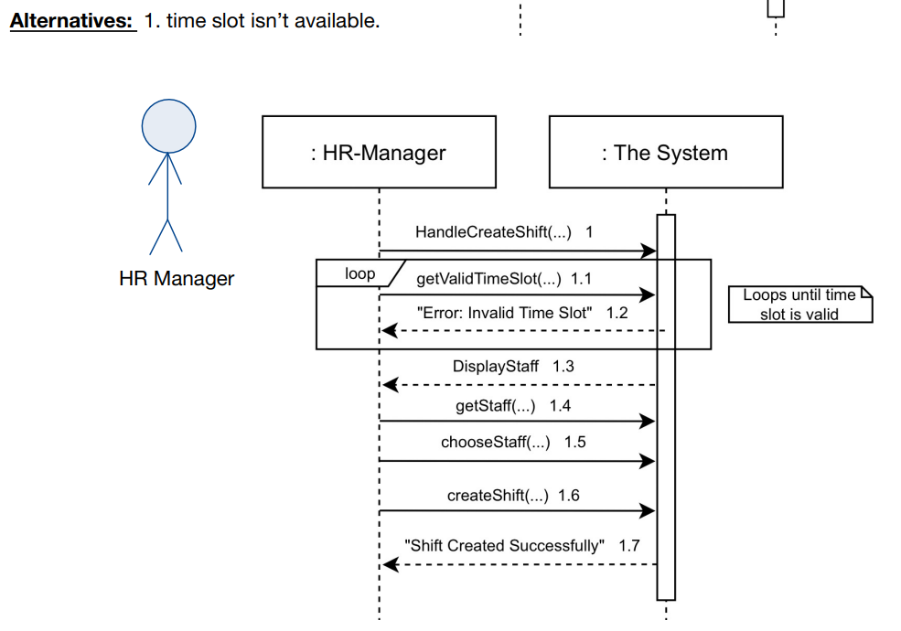

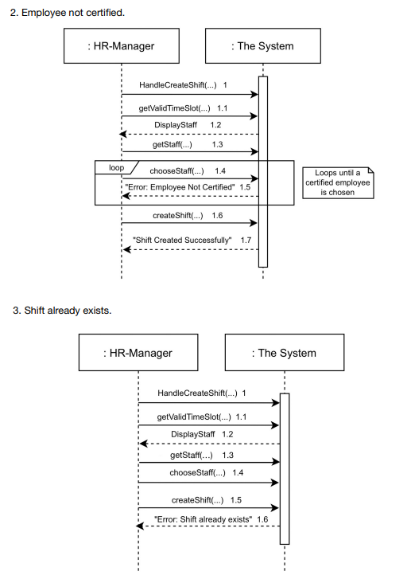

### Use case H:

* Use case name: New Transport.
* Textual Description: a transport manager is ordering a transport with available

and suitable truck and driver, also asks the employee system if a storage keeper

is present at the destination.

If a driver/truck or storage keeper aren’t available/ present then an error will be

displayed.

* List of actors: Transport Manager .
* Pre-conditions: drivers, trucks and a storagekeeper are all available and present.
* Post-condition: a new transport doc is created.
* Main success scenario:

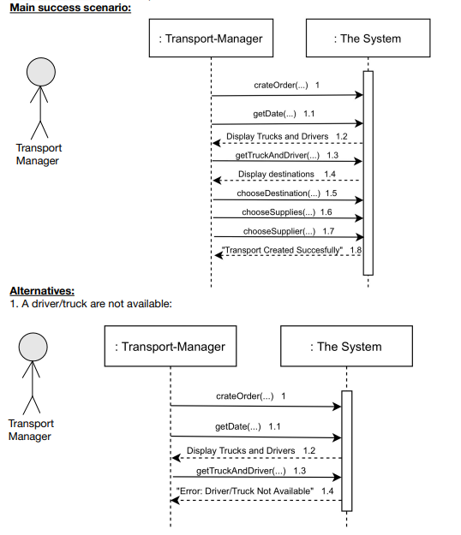

## תרשים A

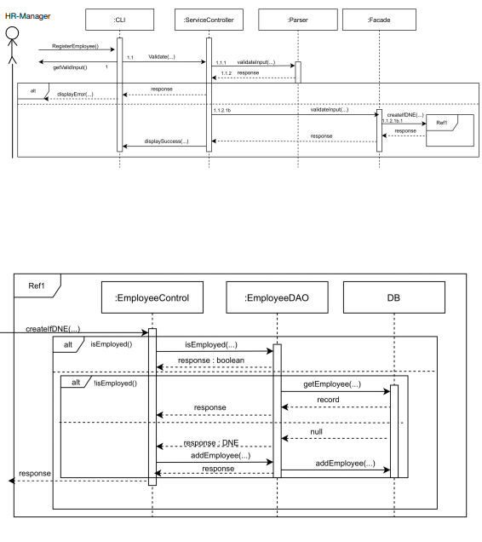

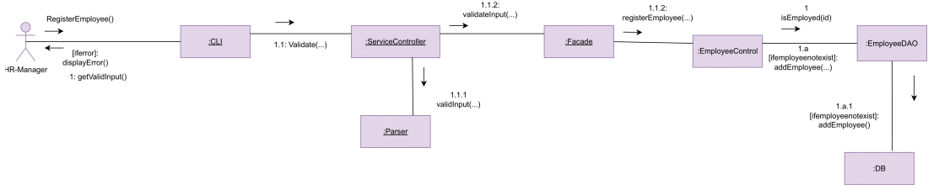

## תרשים B

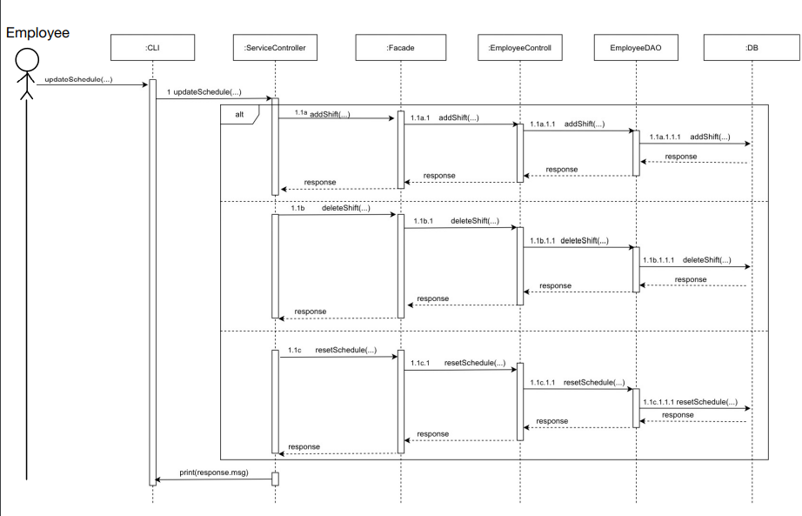

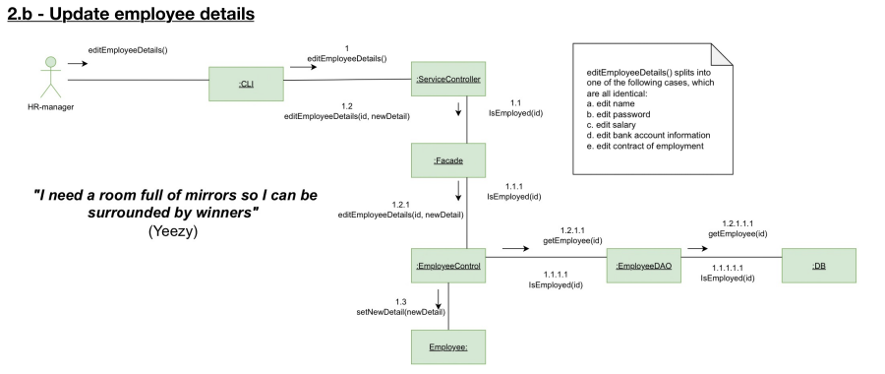

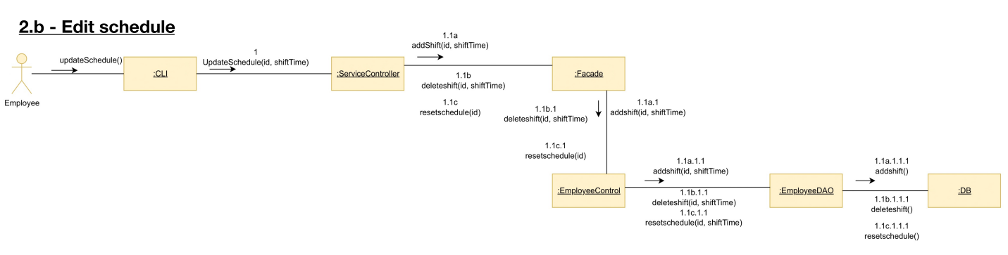

## תרשים C

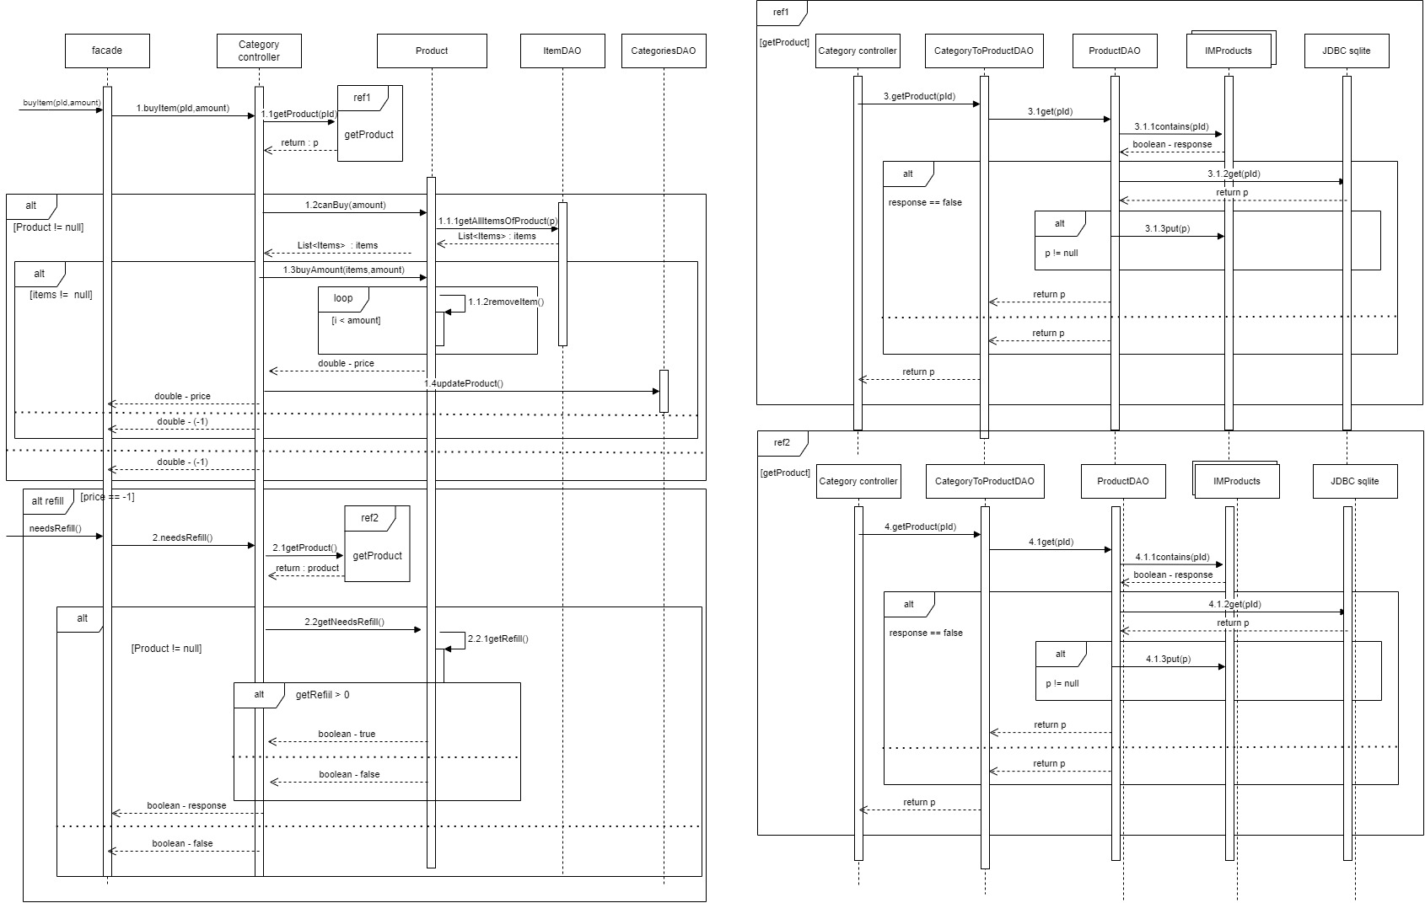**Sequence Diagram c**



**Collaboration Diagram c**

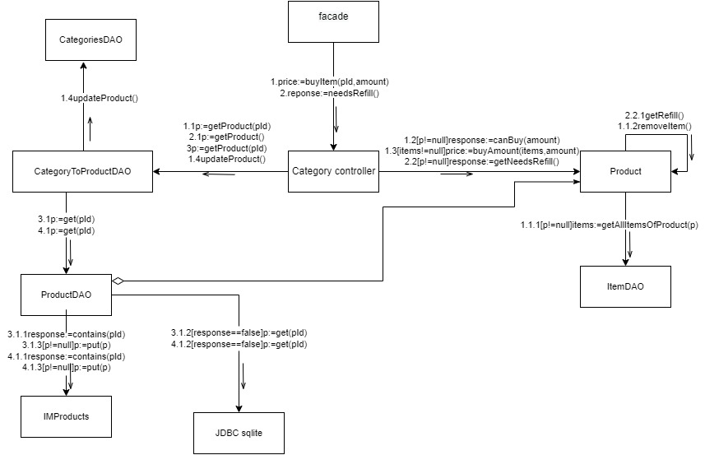

## תרשים D

**Sequence Diagram**

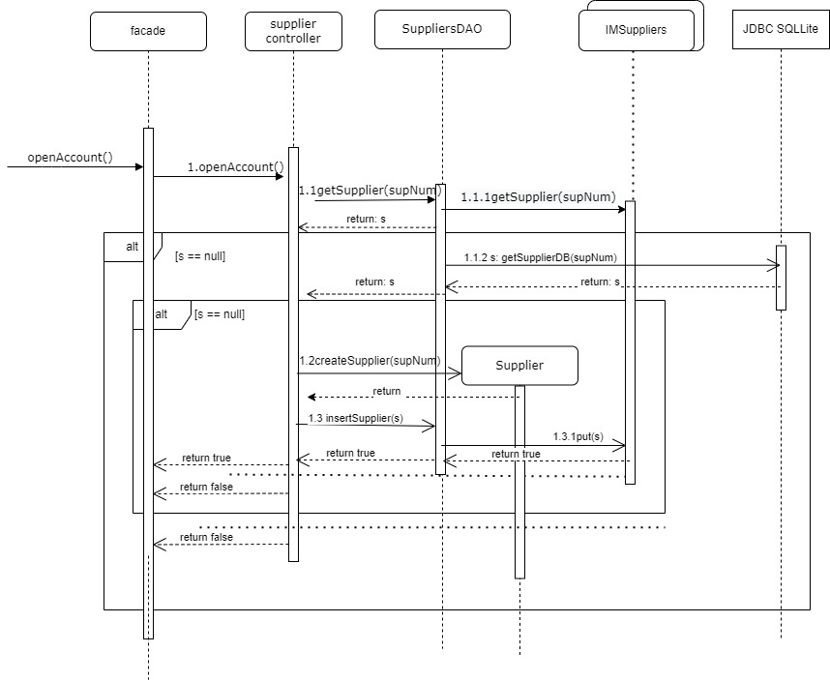

**Collaboration Diagram**

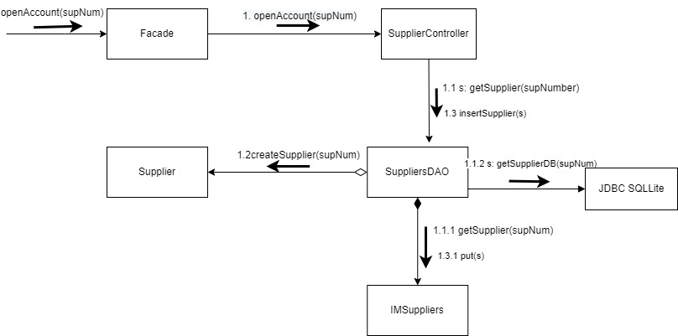

## תרשים אובייקטים:

תרחיש 1:

יום אחד נעשית קניית חלב בחנות, הלקוח יוסי קונה 6 חלב ולאחר מכן נמצא כי ישנו חוסר בחנות, נשאר רק חלב אחד ויש להזמין עוד 11 כדי להגיב לביקוש של חלב. המערכת מנסה לייצר הזמנה אך נמצא כי אין ספק שמביא את החלב המסוים שהחנות רוצה למכור ולכן מוצאים ספק חדש שיש לו את החלב הספציפי שהחנות רוצה. המערכת מייצרת הזמנה חדשה ממנו ולאחר ביצוע ההזמנה הספק ישירות מודיע שההזמנה יצאה ובדרך לחנות.

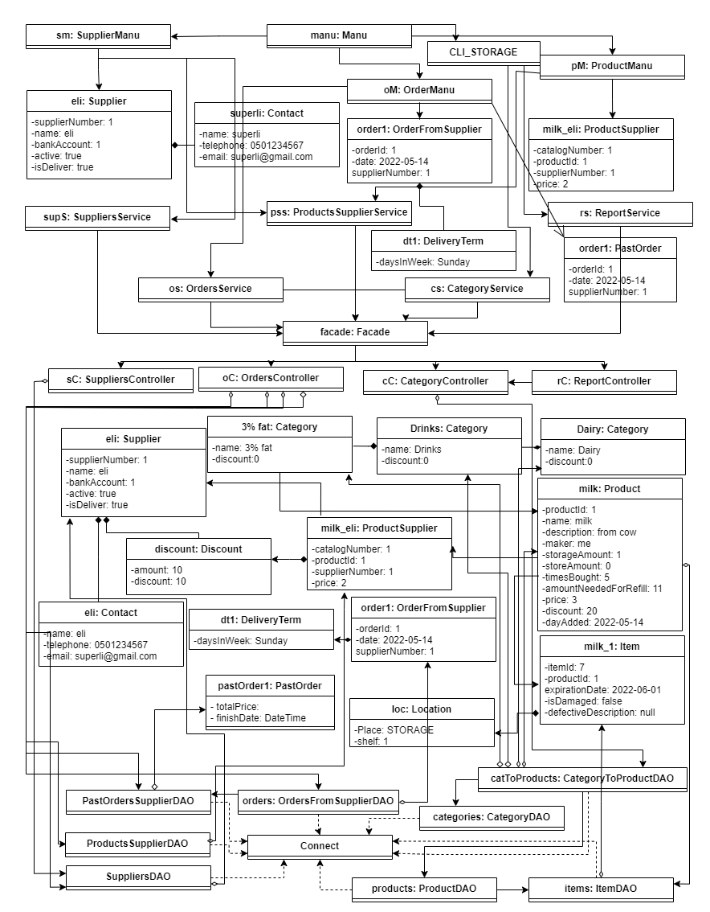

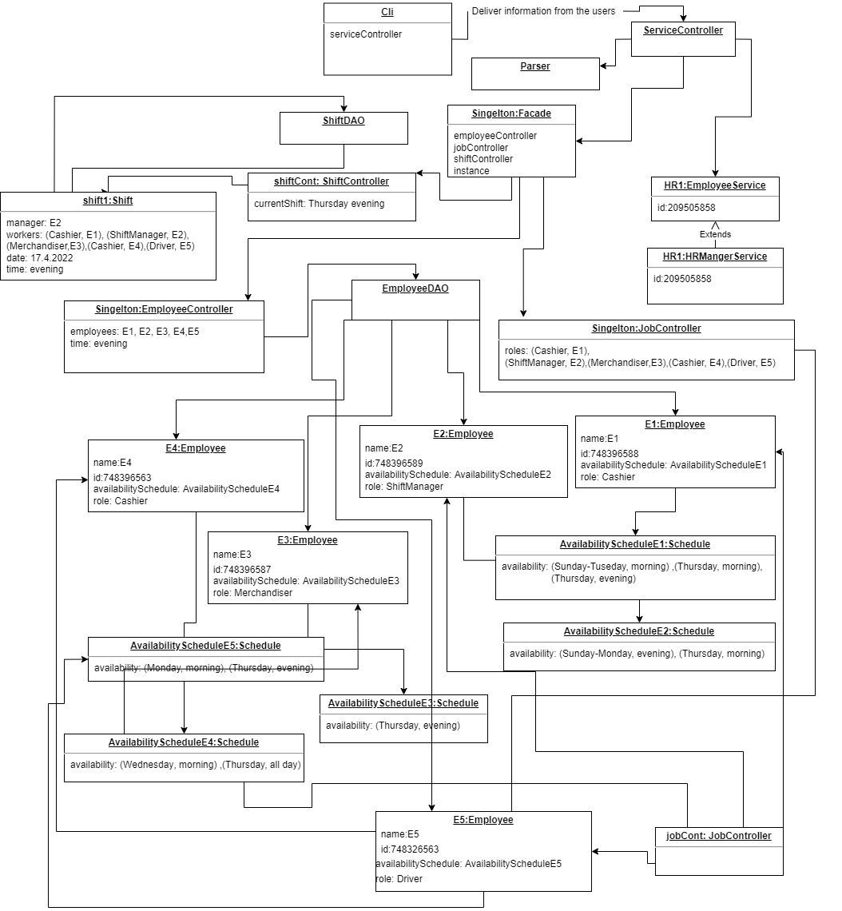

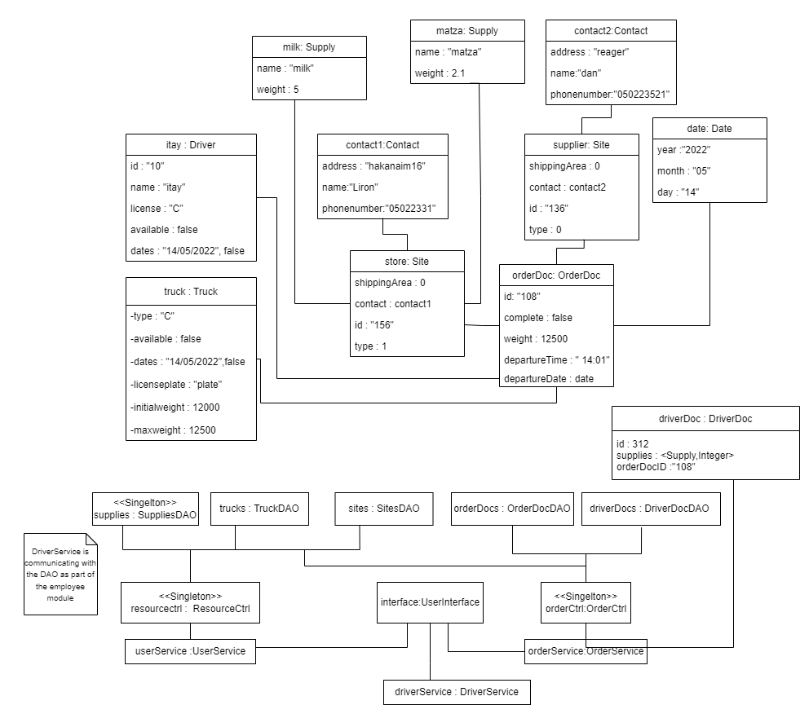

תרחיש 2:

בתחילת היום שמעון (אחראי המלאי) מדליק את המערכת וכתוצאה מכך המערכת עוברת על כל ההזמנות הקבועות ומעדכנת להם את המלאי שהם מביאים לפי החוסרים שיש בחנות. נמצא כי ישנה רק הזמנה קבועה אחת שמספקת לחם וכי עד כה היא אמורה להביא 2 לחם לחנות ביום ראשון. המערכת מוצאת כי מאז נקנה עוד לחם וכעת יש להזמין 5 לחם כדי שיהיה מספיק בחנות ולכן מעדכנת את כמות הלחם בהזמנה.

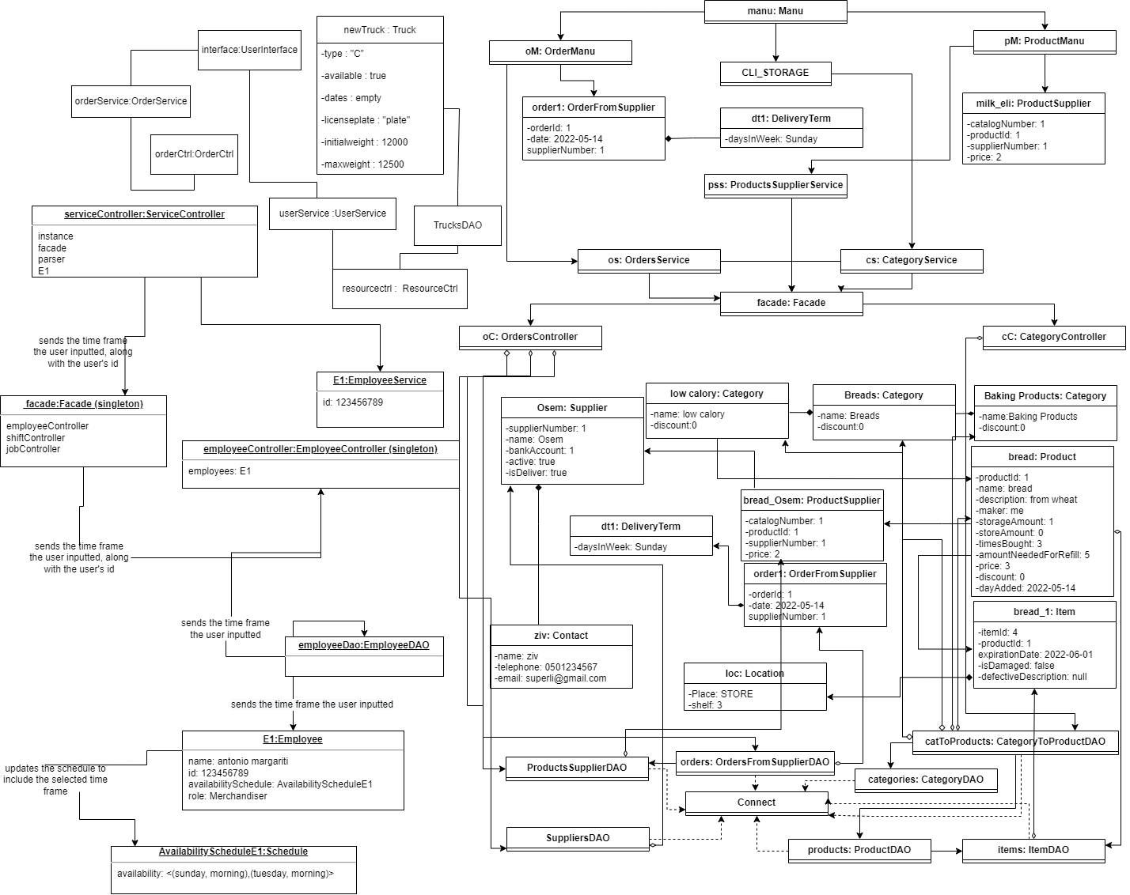

## תרשים ERD

